Pacman
# Source: AI Source: Provided by: [Data Path: Persons Table -> ID Column: 1, Name_En Column: Motasem Essam] -> From: [ChatGPT] on [1/26/2026]
Pacman is the package manager for Arch Linux and its derivatives (like Manjaro).
It is used to install, update, and remove software packages on the system, and it handles dependencies automatically.

Key Features
# Source: AI Source: Provided by: [Data Path: Persons Table -> ID Column: 1, Name_En Column: Motasem Essam] -> From: [ChatGPT] on [1/26/2026]
- Works with .pkg.tar.zst packages (Arch Linux package format)
- Combines package installation, updating, and dependency management in one tool
- Known for being fast, simple, and efficient

Common Pacman Commands
# Source: AI Source: Provided by: [Data Path: Persons Table -> ID Column: 1, Name_En Column: Motasem Essam] -> From: [ChatGPT] on [1/26/2026]
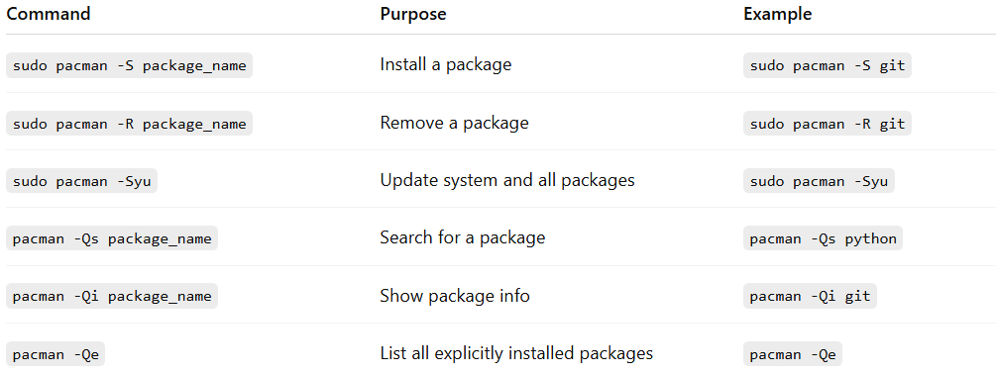
Command | Purpose | Example
sudo pacman -S package_name | Install a package | sudo pacman -S git
sudo pacman -R package_name | Remove a package | sudo pacman -R git
sudo pacman -Syu | Update system and all packages | sudo pacman -Syu
pacman -Qs package_name | Search for a package | pacman -Qs python
pacman -Qi package_name | Show package info | pacman -Qi git
pacman -Qe | List all explicitly installed packages | pacman -Qe

Example
# Source: AI Source: Provided by: [Data Path: Persons Table -> ID Column: 1, Name_En Column: Motasem Essam] -> From: [ChatGPT] on [1/26/2026]
Install Python on Arch Linux:
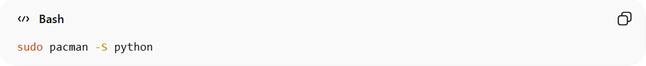
sudo pacman -S python
Check version:
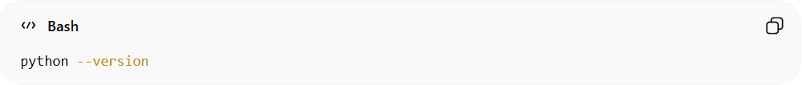
python --version

✅ Summary:
# Source: AI Source: Provided by: [Data Path: Persons Table -> ID Column: 1, Name_En Column: Motasem Essam] -> From: [ChatGPT] on [1/26/2026]
Pacman = system-level package manager for Arch Linux, fast and simple, handles software and dependencies efficiently.

